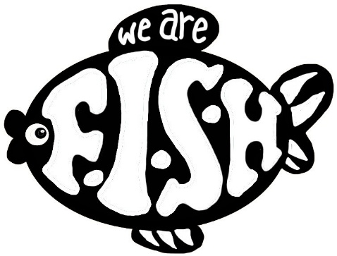

**We Are F.I.S.H CIC Volunteer Induction Pack**

**1. Welcome to We Are Fish CIC**

Dear Volunteer,

Thank you for choosing to volunteer with **We Are F.I.S.H CIC**. We are a community-rooted organisation based in Cleethorpes, committed to empowering families of children and young people with Special Educational Needs and Disabilities (SEND). Volunteers like you are at the heart of what we do, and we are thrilled to welcome you to our team.

This induction pack provides essential information about our mission, your role, expectations, and how we will support you throughout your volunteering journey.

**2. About We Are F.I.S.H CIC**

**Our Mission:**  
To empower families and individuals with SEND through inclusive programmes, community connection, advocacy, and skills-building opportunities.

**Our Values:**

* **Inclusion** – Everyone belongs.
* **Empowerment** – Creating opportunities for individuals to thrive.
* **Respect** – Valuing lived experience, culture, and dignity.
* **Community-Led** – Shaped by the voices of those we support.
* **Partnership** – Working collaboratively with families, professionals, and allies.

We deliver social sessions, community engagement, family workshops, wellbeing activities, and inclusive events designed to foster belonging, confidence, and resilience.

**3. Volunteer Roles and Responsibilities**

**Volunteering Opportunities May Include:**

* Supporting children and young people in social and creative sessions
* Helping at community events and workshops
* Contributing to planning and admin tasks
* Promoting inclusion and positive attitudes towards SEND
* Assisting with setup, refreshments, and safe environments

**As a volunteer, you are expected to:**

* Be present, punctual, and fully engaged during sessions
* Follow direction from your assigned supervisor or session lead
* Maintain the dignity and confidentiality of families
* Raise concerns or incidents promptly with the safeguarding lead
* Uphold our values in all interactions

**4. Volunteer Standards and Conduct**

As a representative of We Are F.I.S.H CIC, we expect all volunteers to:

* **Be Reliable:** Notify us in advance if you’re unable to attend
* **Be Respectful:** Listen actively and value diverse experiences
* **Maintain Boundaries:** Keep professional, appropriate relationships
* **Work Inclusively:** Help create welcoming spaces for all participants
* **Champion Safeguarding:** Follow procedures and report concerns

**5. Key Policies and Procedures**

* **Safeguarding:** You will receive training and must report any concerns to our Safeguarding Lead.
* **Health & Safety:** Follow guidelines at each venue. Be aware of risk assessments and emergency protocols.
* **Confidentiality:** Do not share personal information about participants outside the team.
* **Equality & Diversity:** We embrace difference and expect volunteers to uphold anti-discriminatory practice.
* **DBS Checks:** All volunteers in contact with children or vulnerable adults must complete a DBS check.

**6. Training and Support**

We want every volunteer to feel confident, supported, and valued. We provide:

* **Initial Induction:** Including an introduction to our work and SEND-awareness
* **Mandatory Training:** On safeguarding, health and safety, and inclusivity
* **Ongoing Support:** Regular check-ins, team meetings, and opportunities to reflect and grow
* **Supervision:** You will be assigned a named contact for guidance and feedback

**7. Communication and Feedback**

We value your ideas and input. Volunteers are encouraged to share feedback during debriefs or directly with their supervisor. Open communication helps us continually improve and support your development.

**8. Practical Information**

* **Hours:** Your schedule will be arranged in advance. Flexibility is appreciated.
* **Expenses:** Reasonable travel or agreed costs may be reimbursed – please speak with your supervisor.
* **Dress Code:** Comfortable, modest clothing suitable for indoor and outdoor family activities.

**9. Ways to Get Involved**

You might support us through:

* **Weekly Programmes** – Social sessions and holiday activities
* **One-Off Events** – Community fairs, awareness days, and fundraisers
* **Behind-the-Scenes** – Office support, communications, or helping with funding bids

Let us know what excites you, and we’ll match you with the right opportunities.

**Volunteer Agreement and Acknowledgment**

Please sign to confirm you have read and understood this induction pack and agree to follow our policies and expectations while volunteering with We Are F.I.S.H CIC.

**Name:** ______________________  
**Signature:** ______________________  
**Date:** _____________________

**10. Thank You**

Volunteers make our vision possible. We truly value your time, passion, and commitment. Together, we are helping to build a more inclusive and supportive community.

We look forward to growing with you.

Warm regards,  
**Sandra Ritchie**  
Founder & CEO  
We Are F.I.S.H CIC

**Contact Information**

We Are F.I.S.H CIC  
Sussex Pavilion, Brereton Avenue, Cleethorpes, DN35 8AB  
📞 01472 470603  
✉️ catchus@wearefish.org.uk  
🌐 [www.wearefish.uk](http://www.wearefish.uk)